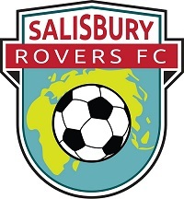
PLAYERS’ IDEAS
DO YOU HAVE ANY IDEAS FOR YOUR CLUB?
WHAT DO YOU LIKE DOING IN FOOTBALL?
WHAT DON’T YOU LIKE DOING?
Write or draw YOUR IDEAS here!

